5.94: The banked angle of the track has the same form as that found in Example 5.24, 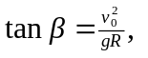 where  is the ideal speed, 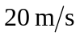 in this case. For speeds larger than 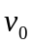, a frictional force is needed to keep the car from skidding. In this case, the inward force will consist of a part due to the normal force n and the friction force 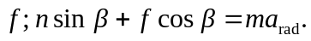 The normal and friction forces both have vertical components; since there is no vertical acceleration, 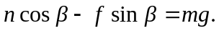 Using 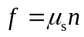 and 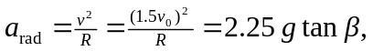 these two relations become
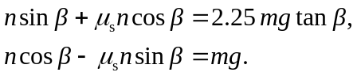
Dividing to cancel n gives
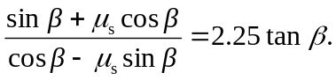
Solving for 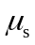 and simplifying yields
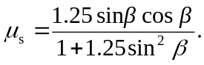
Using 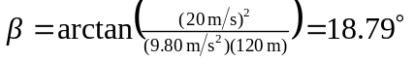 gives 